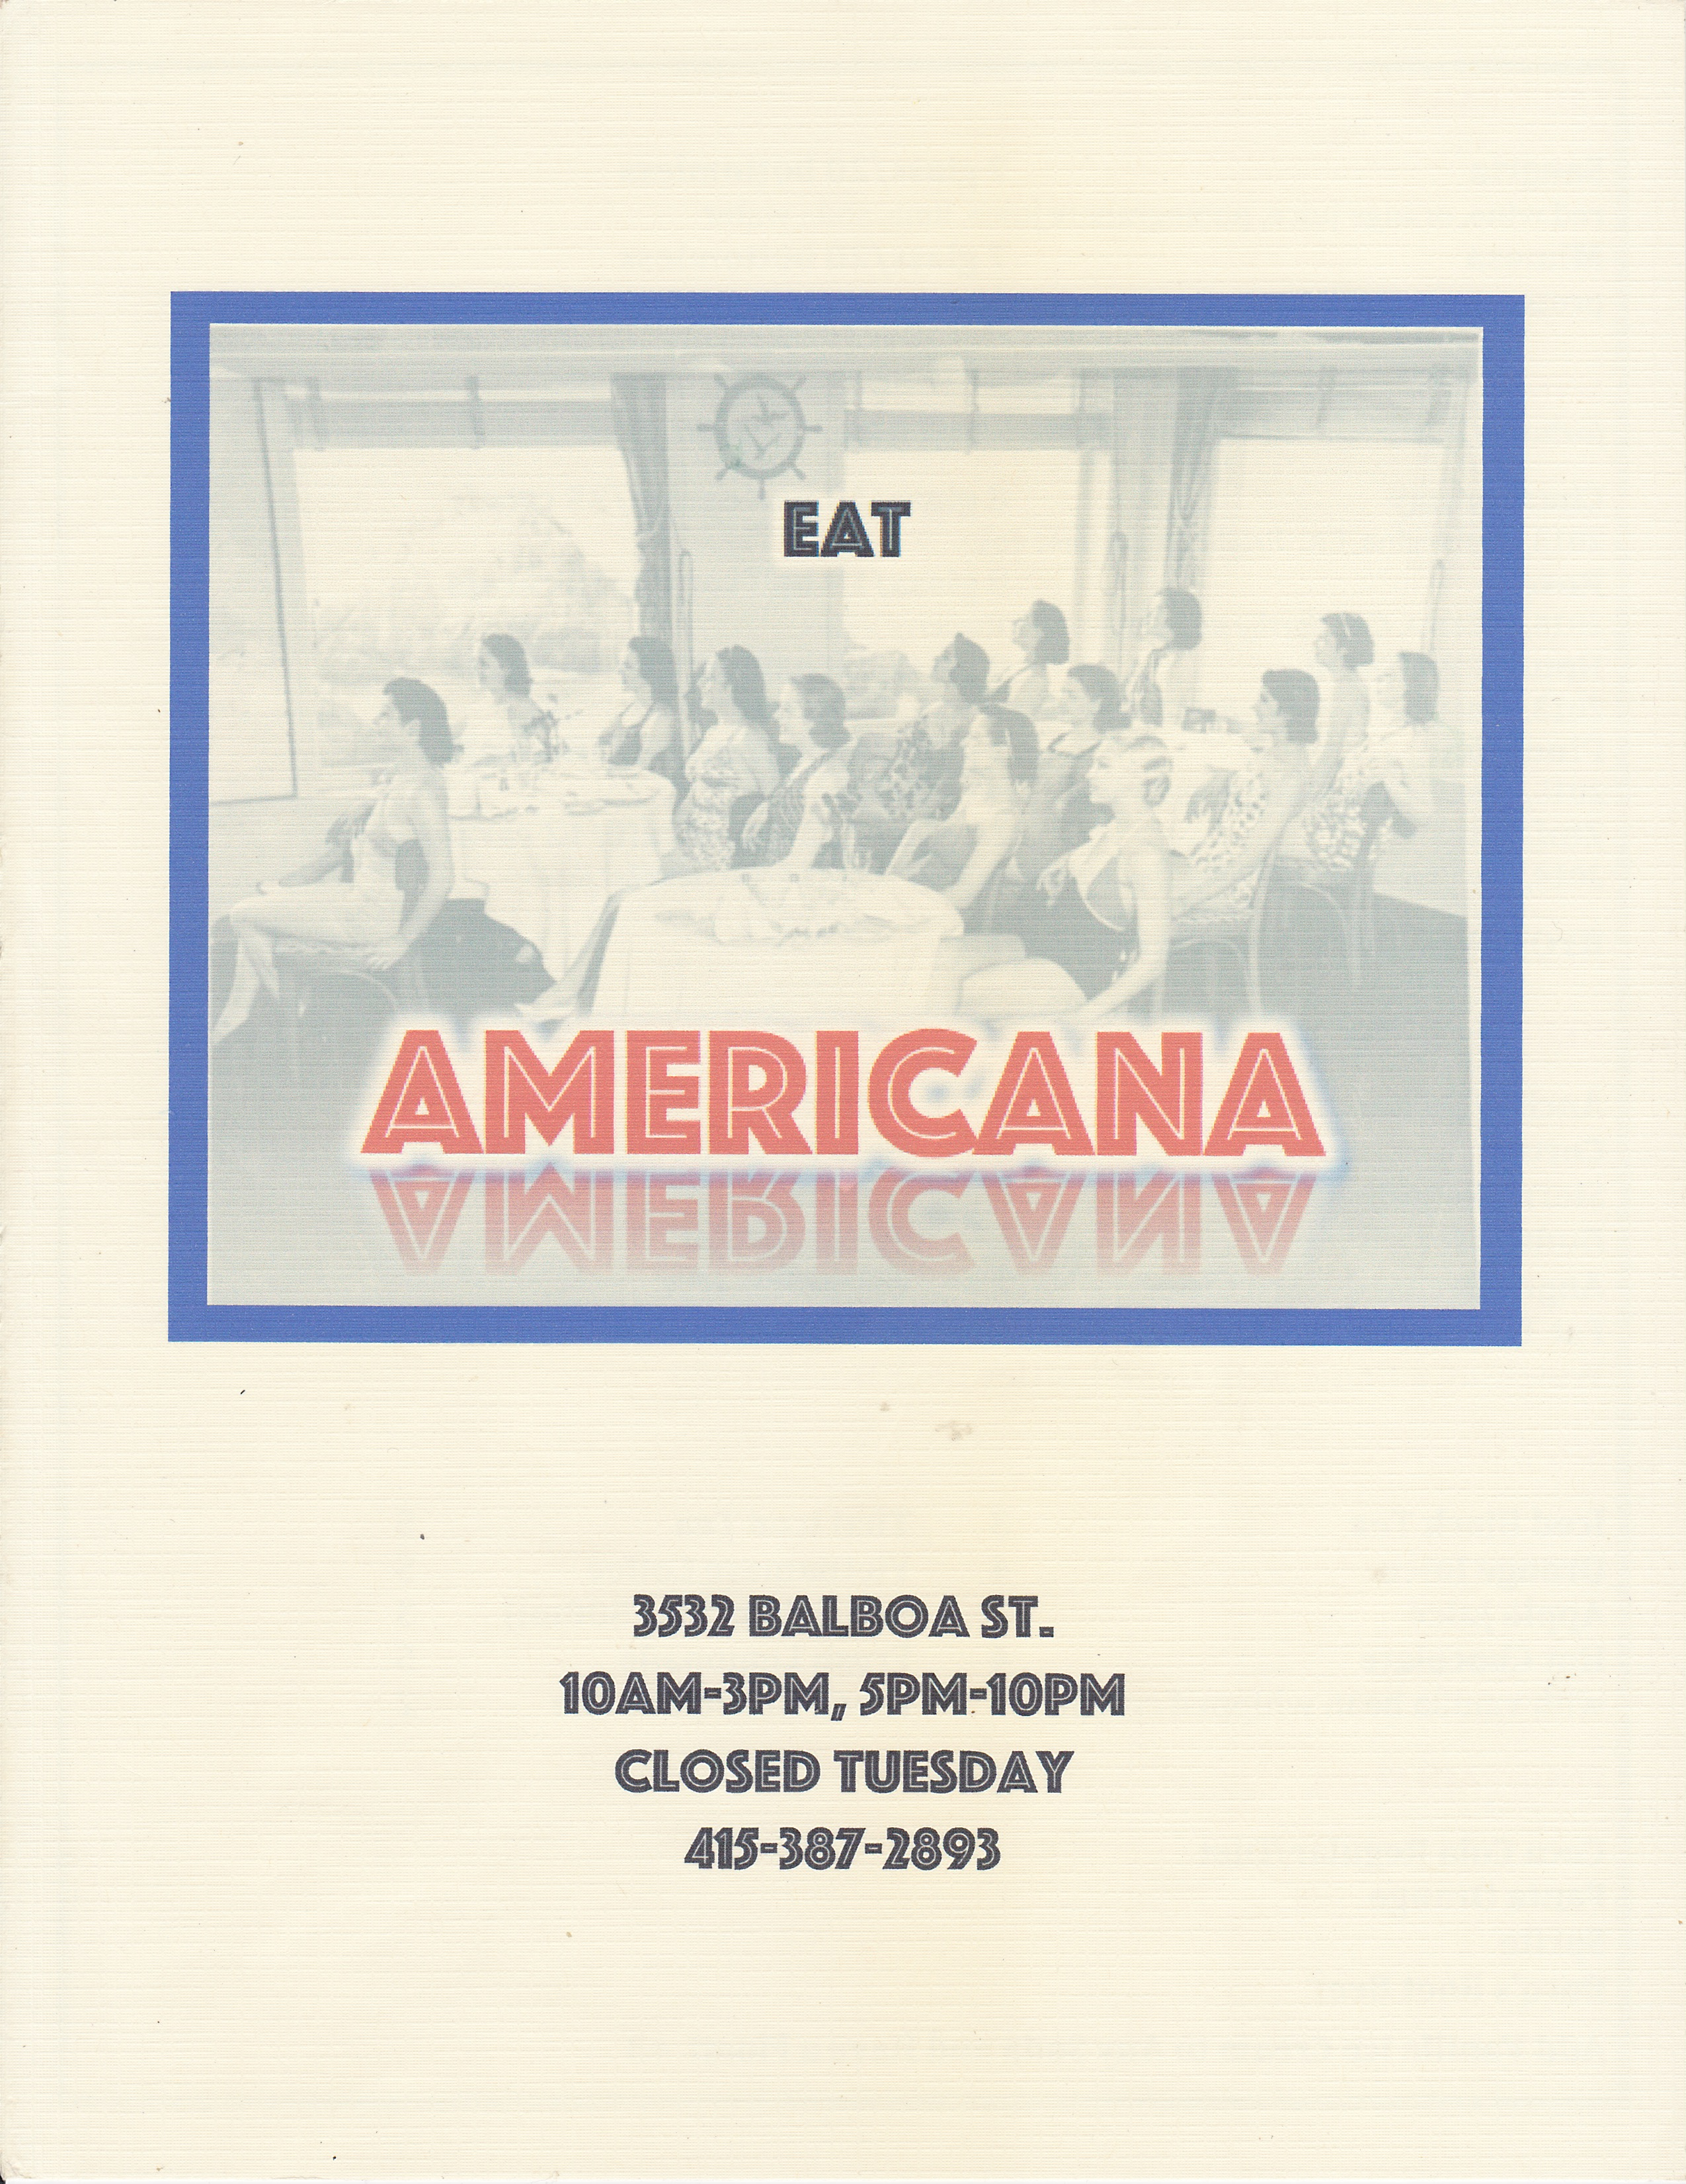

ALL DAY BREAKFAST substitute egg whites +2 * designates gluten-free item
Farm Egg Breakfast* 9
2 eggs, fried or scrambled, served with our hash browns
Add Sausage, Chopped Bacon, Mushrooms, or Avocado to your egg…+2

B.A.T. Scramble* 13
egg scramble of bacon, avocado, tomato, cheese & scallion, with house hash browns
Breakfast Burrito 14
scrambled eggs, cheddar cheese, hash browns, sausage, peppers & onions, salsa, sour cream

Griddled Sausage & Grits* 12
Butterflied and fried Andouille sausage, cheddar grits, 2 sunny-side eggs, scallion

Short Rib Hash* 17
cheddar cheese hash browns, slow cooked short ribs, peppers & onions, 2 sunny-side eggs
Pumpkin Pancakes 13
2 pumpkin pancakes with butter, maple syrup & candied pecan, choice of fried or scrambled eggs
Buttermilk Pancakes 10
2 pancakes with butter and maple syrup, your choice of fried or scrambled eggs

Americana Omelet* 13
Mom’s Tea
Buttermilk biscuit,
Small green salad,
Fresh fruit,
& Choice of Tea
13

cheddar cheese, bell pepper, onion, tomato, with house hash browns

Add Sausage, Chopped Bacon, Mushrooms, or Avocado inside…. +2
California Omelet* 14
sautéed spinach, cherry tomatoes, roasted garlic, swiss cheese, avocado on top, with hash browns

Bread Pudding French Toast 14
bananas and berries, maple syrup, hand whipped vanilla cream

Country Biscuit Plate 12
Green Chile Burger!
choice of burger patty,
roasted hatch green chiles,
shaved red onion,
cheddar cheese,
spicy mayo

12

sausage gravy and 2 sunny-side eggs over toasted buttermilk biscuit (Ask for vegetarian gravy!)
Chicken & Pancake Stack 14
Green Chile Burger!
choice of burger patty,
roasted hatch green chiles,
shaved red onion,
cheddar cheese,
spicy mayo

12

one buttermilk pancake topped with a fried chicken breast, two bacon strips, maple syrup & butter
BREAKFAST SIDES. 4 each. Andouille Sausage*
3 Strips Griddled Bacon*
Breakfast Pork Sausage Patty*.
Chicken Apple Sausage*

Buttermilk Biscuit with jam & honey butter

Fruit Plate
Green Chile Burger!
choice of burger patty,
roasted hatch green chiles,
shaved red onion,
cheddar cheese,
spicy mayo

12

Wheat or White Toast +2

SANDWICHES Add Fries +3 or Side Salad +4
Pulled Pork Sandwich 11
Dijon mustard coleslaw, spicy mayo, brioche bun
Philly Cheesesteak 12
shaved ribeye steak, peppers & onions, American cheese
Andouille Sausage Sandwich 11
butterflied and griddled with a cheddar cheese skirt, topped with coleslaw
Impossible Burger Time ! 14
Meatless wonder burger, American cheese, 1000 Island, lettuce, brioche bun
Burger Time! Beef & Bacon Patty or All Beef Patty 12
American cheese, 1000 island, lettuce, shaved red onion, brioche bun
Fried Chicken Sandwich 14
Tomatillo-jalapeno coleslaw, charred scallion ranch dressing mayo
Grilled Cheese & Tomato Soup 10
Texas toast, cheddar & American cheese, creamy tomato soup, chives (Add chopped bacon…. +2)
STARTERS * designates gluten-free item
Sweet Potato Tater Tots* 8
charred scallion ranch dip

Pulled Pork Waffle Fries* 12
house cheese sauce, buffalo sauce, scallions

Roasted Brussels Sprouts* 9
Oven-roasted in garlic and olive oil, tossed with parmesan & chile flakes

Crispy Chicken Wings* 9
tossed in house buffalo sauce, celery and blue cheese dressing
Cheesy Grits* 6
creamy cheddar grits topped with parmesan and scallion. Add Bacon +2
Warm Red Beets* 9
roasted and marinated beets, rich Greek yogurt dip. Add Pita + 2
SALADS
Baby Spinach & Goat Cheese Salad* 10
Roasted red beets, shaved fennel, balsamic vinaigrette

Granny’s Apple Salad* 10
mixed greens, crumbled blue cheese, shaved celery, candied pecans, house vinaigrette
Main Lobster Mac & Cheeses $21

MAIN PLATES Add Side Garlic Bread +3
Shrimp & Grits* 18
Sautéed shrimp, spicy lobster-tomato broth, Andouille sausage, cheddar grits, scallion
Poor Man’s Steak Frites* 16
onion-smothered beef patty, creamy cremini mushroom sauce, fries

Halloumi Plate 18
Olive oil-griddled eggplant & Halloumi cheese, Greek salad, warm pita

Short Rib Lasagna 20
braised short ribs, portabella mushroom, mozzarella, pesto, tomato sauce, house ricotta, basil

Chicken Parm 16
fried chicken breast, mozzarella and parmesan, house tomato sauce, basil, garlic bread

Pan-Roasted Salmon* 21
baby beets, sautéed spinach, sherry-lobster cream sauce

Crispy Risotto Cakes 17
stuffed with goat cheese & chive, served over a roasted squash, cherry tomato & arugula salad

Green Chili Mac & Cheese 14
penne pasta, New Mexico hatch chili, asiago, parmesan, Wisconsin cheddar, fontina, scallions
add bacon, sausage, or mushrooms +2 … add braised short rib +7
Pork Tenderloin* 19
Thai chili glaze, sautéed Napa cabbage and mushroom, butternut squash & coconut milk pure
DESSERT
Ballpark Ice Cream Sundae 8
Double Rainbow vanilla ice cream, warm fudge sauce, roasted peanuts, toffee & snickers crumble
Bread Pudding French Toast 14/full order … 8/half order
bananas and berries, maple syrup, hand whipped vanilla cream
Mini Pecan Pie 7
with hand whipped vanilla cream add Double Rainbow ice cream +3

COCKTAILS 9 each
Sangria
red wine, orange juice, pomegranate juice, lime, soda water
Michelada (22 oz)
Corona, house tomato cocktail, chile-salt rim
Mimosa
prosecco, orange juice

WINE BY THE BOTTLE 32/ Bottle
Sauvignon Blanc, Château Puy-Servain
2018, IGP Périgord, Dordogne River, Southwestern France
100% Sauvignon Blanc; great acidity, hint of fruit. Light in body; great with salads, vegetables, and cheeses
Merlot, Château Puy-Servain
2016, IGP Périgord, Dordogne River, Southwestern France
100% Merlot; soft, less tannic Bordeaux; ripe fruit flavors, balanced acidity with subtle oak finish

WINE FROM THE TAP featuring Green Barrel Wine Merchants, SF eco-friendly purveyor
Chardonnay. 9 glass/23 half carafe (= 3 glasses)
Bright and unique wine from Mendocino with citrus and light oak.
Sauvignon Blanc 9 glass/23 half carafe (= 3 glasses)
2018, IGP Périgord, Dordogne River, Southwestern France
House Red Blend 9 glass/23 half carafe (= 3 glasses)
2013, Sonoma, CA. Syrah-based, ripe berry and vanilla notes, spicy oak finish
Merlot, Château Puy-Servain 9 glass/23 half carafe (= 3 glasses)
2016, IGP Périgord, Dordogne River, Southwestern France
Pinot Noir 10 glass/25 half carafe (= 3 glasses)
2015, Sonoma, CA. Delicate and smooth, smoky finish.
Zinfandel 10 glass/25 half carafe (= 3 glasses)
2014, Dry Creek, CA. Old Vine Zin, with beautifully nuanced and complex flavors

BEER & CIDER
Anchor Steam 6 Scrimshaw Pilsner 7
Corona 6 Allagash White Ale 7
Angry Orchard Hard Cider 6 Eel River Blonde Ale 7
Stella Artois 6 Racer 5 IPA 7
Lagunitas IPA 6

SOFT DRINKS
Fresh Ground Coffee dark roast 4 Iced Black Tea 3
Hot Chocolate with whipped cream 4 Thai Iced Tea 6
Milk whole milk or almond milk 3 Fresh Squeezed Lemonade 6
Orange Juice 4 Vietnamese Coffee 6
Apple Juice 3 San Pellegrino (500ml) 3
Hot Teas Green, Earl Grey, English Breakfast, Chai Spice, Mint, Chamomile, Jasmine 3

FOUNTAIN SODA 3
Coca Cola Regular/Diet Sprite
Fanta Orange Barq’s Root Beer
Add Vanilla Ice Cream to Any Soda and Have a Float! +3

A 4% Standard Processing fee will be applied to all Credit/Debit Card Sales
Pay by Cash & Save

